MODULE 2
Module - 2

BIOMOLECULES AND THEIR APPLICATIONS (QUALITATIVE)
APPLICATION OF BIOMOLECULES
Carbohydrates in cellulose-based water filters production, PHA and PLA in bioplastics production, Nucleic acids in vaccines and diagnosis, Proteins in food production, lipids in biodiesel and detergents production, Enzymes in biosensors fabrication, food processing, detergent formulation and textile processing.

What are carbohydrates?
Carbohydrates, or carbs, are sugar molecules. Along with proteins and fats, carbohydrates are one of three main nutrients found in foods and drinks. Body breaks down carbohydrates into glucose. Glucose, or blood sugar, is the main source of energy for your body's cells, tissues, and organs. Glucose can be used immediately or stored in the liver and muscles for later use.

There are three main types of carbohydrates:

- Sugars: They are also called simple carbohydrates because they are in the most basic form. They can be added to foods, such as the sugar in candy, desserts, processed foods, and regular soda. They also include the kinds of sugar that are found naturally in fruits, vegetables, and milk. Starches. They are complex carbohydrates, which are made of lots of simple sugars strung together. Your body needs to break starches down into sugars to use them for energy. Starches include bread, cereal, and pasta. They also include certain vegetables, like potatoes, peas, and corn. Fiber. It is also a complex carbohydrate. Your body cannot break down most fibers, so eating foods with fiber can help you feel full and make you less likely to overeat. Diets high in fiber have other health benefits. They may help prevent stomach or intestinal problems, such as constipation. They may also help lower cholesterol and blood sugar. Fiber is found in many foods that come from plants, including fruits, vegetables, nuts, seeds, beans, and whole grains.
Just like starches, cellulose is another best example for carbohydrates.

- Cellulose: a complex carbohydrate, or polysaccharide, consisting of 3,000 or more glucose units.
It is extremely abundant, easily renewable, and biodegradable. Due to inter- and intramolecular hydrogen bonding between the hydroxyl groups of the neighboring cellulose chains, cellulose is insoluble in water, despite being hydrophilic, and is difficult to dissolve with common organic solvents.

Taking benefit of these advantages of cellulose, we have a best application of cellulose, that is,
Cellulose-based water filters.

The interest in the use of biobased filters for water purification has increased in recent years, as such filters have the potential to be affordable, lightweight and biodegradable. Research has been focused on creating biobased membranes for micro- and ultrafiltration from cellulose nanofibrils (CNFs).
Filters based on cellulose pulp fibers do usually have large pores that facilitate water percolation but they do not sufficiently remove bacteria through size exclusion; other techniques are therefore needed to achieve a bacteria-reducing effect. Several groups have addressed this issue by incorporating antibacterial metal nanoparticles into cellulose-based water filters; both silver nanoparticles (AgNPs) and copper nanoparticles (CuNPs) are known to have good antibacterial effects.
An alternative method to physically remove bacteria from water, while keeping the filter pore size larger than bacteria, is to use positively charged filters that adsorb negatively charged bacteria onto the surfaces of the filters.

This allows negatively charged particles much smaller than the filter pore size to be efficiently removed from water and this is an interesting approach for removing bacteria from water without adding any toxic chemicals or reducing the flow by reducing the pore size. Both Gram-positive and Gram-negative bacteria have a negative net surface charge on the cell envelope, due to peptidoglycans, liposaccharides and proteins in the cell wall, and this makes their removal non- selective and efficient for most types of bacteria.
Methods used for the same are:

- LBL [Layer By Layer] MODIFICATION
- NITROGEN ANALYSIS
- SEM [ Scanning Electron Microscope]
- FLOW RATE FOR FREE FLOW FILTRATION
- BACTERIAL REMOVAL EFFICIENCY OF FILTRATION
- FILTRATION OF NATURAL WATER SAMPLES
- FLOURESCENCE MICROSCOPY

Cellulose filter papers are versatile and diverse tools for microfiltration, that work by trapping particulates within a random matrix of cellulose fibers. Cellulose filter papers can be categorized as quantitative or qualitative, depending on their application.

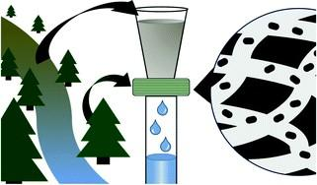
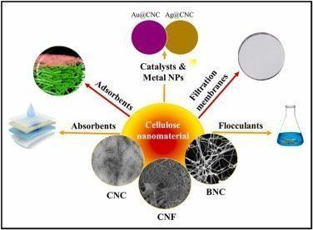
Cellulose based nanomaterials for water treatment

POLY LACTIC ACID [PLA] AND POLYHYDROXYALKANOATES [PHA]:

Just like, how we introduced biodegradable water treatment plant from cellulose, we also have a replacement for toxic, non-biodegradable plastics which we are using in our daily life. That is, Bioplastics.
Bioplastics are one type of plastic which can be generated from natural resources such as starches and vegetable oils. Bioplastics are basically classified as bio based and/or biodegradable. Not all bio-based plastics are biodegradable and similarly not all biodegradable plastics are bio based. Bioplastics are referred to as bio based when the focus of the material is on the origin of the carbon building block and not by where it ends up at the end of its cycle life. Bio plastics are said to be biodegradable if they are broken down with the effect of the right environmental conditions and microbes which in turn use them as a food source. The bioplastics are considered compostable if within 180 days, a complete microbial assimilation of the fragmented food source takes place in a compost environment.
Based upon this, we have PHA and PLA.

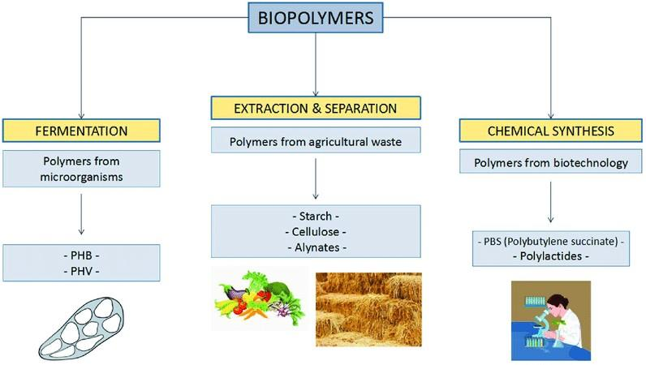

Production of biopolymers

PLA is both: biobased and biodegradable under industrial composting conditions (at a high temperature, around 58 °C). Because of its good mechanical properties, processability, renewability, and non-toxicity, PLA is considered today as one of the most commercially promising bioplastics. When compared with most other biodegradable polymers, PLA has better durability, transparency, and mechanical strength.

PHAs are a significant polymer family that are 100% bio-based and bio-degradable. PHAs are microbiologically produced polyesters that have tunable physical and mechanical properties. This is accompanied by low environmental impact due to their biodegradability and non-toxicity nature. Therefore, they are promising candidates for a sustainable future manufacturing. Ranging from brittle thermoplastics to gummy elastomers, PHAs' properties can be altered by the selection of bacteria, fermentation conditions, and substrate. Due to their flexible properties, PHAs can eventually substitute PP, polyethylene (PE), and polystyrene (PS), which are the main polymers of today's global polymer market.
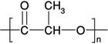
PLA 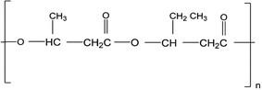 PHA

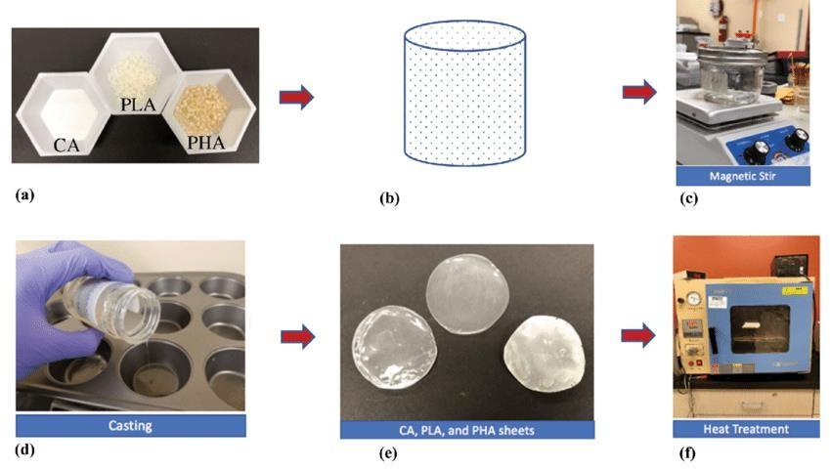
STEPS IN PRODUCING BIOPLASTIC FROM PHA AND PLA

NUCLEIC ACID:

Nucleic acids are biopolymers, macromolecules, essential to all known forms of life.They are composed of nucleotides, which are the monomers made of three components: a 5-carbon sugar, a phosphate group and a nitrogenous base. The two main classes of nucleic acids are deoxyribonucleic acid (DNA) and ribonucleic acid (RNA). If the sugar is ribose, the polymer is RNA; if the sugar is the ribose derivative deoxyribose, the polymer is DNA.

Nucleic acids are naturally occurring chemical compounds that serve as the primary information- carrying molecules in cells and make up the genetic material. Nucleic acids are found in abundance in all living things, where they create, encode, and then store information of every living cell of every life-form on Earth. In turn, they function to transmit and express that information inside and outside the cell nucleus to the interior operations of the cell and ultimately to the next generation of each living organism. The encoded information is contained and conveyed via the nucleic acid sequence, which provides the 'ladder-step' ordering of nucleotides within the molecules of RNA and DNA. They play an especially important role in directing protein synthesis.
Strings of nucleotides are bonded to form helical backbones—typically, one for RNA, two for DNA—and assembled into chains of base-pairs selected from the five primary, or canonical, nucleobases, which are: adenine, cytosine, guanine, thymine, and uracil. Thymine occurs only in DNA and uracil only in RNA.
The two main nucleic acids are DNA and RNA,which is the fundamental unit of any living organisms. Based on these factors, there are many applications for the same, some of which are explained below:

- DNA VACCINE FOR RABIES:

Rabies is a preventable viral disease most often transmitted through the bite of a rabid animal. The rabies virus infects the central nervous system of mammals, ultimately causing disease in the brain and death. Most rabies cases reported to the Centers for Disease Control and Prevention (CDC) each year occur in wild animals like bats, raccoons, skunks, and foxes, although any mammal can get rabies.

A DNA vaccine, using a pCl-neo plasmid encoding the glycoprotein gene of a Mexican isolate of rabies virus, was developed to induce long-lasting protective immunity against rabies virus in dogs. The worldwide incidence of rabies and high rates of therapy failure, despite availability of effective vaccines indicate the need for timely and improved prophylactic approaches. DNA vaccination based on optimized formulation of lysosome-targeted glycoprotein of the rabies virus provides potential platform for preventing and controlling rabies. A range of parameters including physical, physiological, clinical, immunological, hematological along with histopathology profiles of target organs was monitored to assess the impact of vaccination. There were no observational adverse effects despite high dose administration of the DNA vaccine formulation. Thus, this study indicates the safety of next generation of vaccines as well as highlights their potential application.
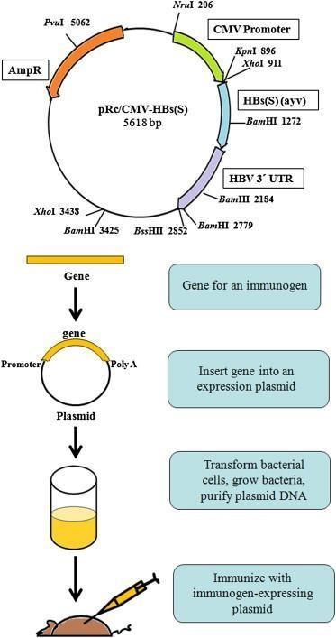
DNA Vaccine production
COURTESY: BABIUK

- RNA VACCINES FOR COVID-19:

Coronavirus disease (COVID-19) is an infectious disease caused by the SARS-CoV-2 virus. Messenger RNA, or mRNA technology, instructs cells to make a protein that generates an immune response in the body, thus producing the antibodies that provide protection against a disease.
It is the basis for the Pfizer/BioNTech and Moderna COVID-19 vaccines being used by governments worldwide, and in the UN-supported COVAX global vaccine solidarity initiative. Messenger ribonucleic acid (mRNA) is a molecule that provides cells with instructions for making proteins. mRNA vaccines contain the instructions for making the SARS-CoV-2 spike protein. This protein is found on the surface of the virus that causes COVID-19.

The mRNA molecule is essentially a recipe, telling the cells of the body how to make the spike protein. COVID-19 mRNA vaccines are given by injection, usually into the muscle of the upper arm. After the protein piece is made, the cell breaks down the instructions and gets rid of them. The mRNA never enters the central part (nucleus) of the cell, which is where our DNA (genetic material) is found. Your DNA can't be altered by mRNA vaccines.

The cell then displays the protein piece on its surface. Our immune system recognizes that the protein doesn't belong there and begins building an immune response and making antibodies.

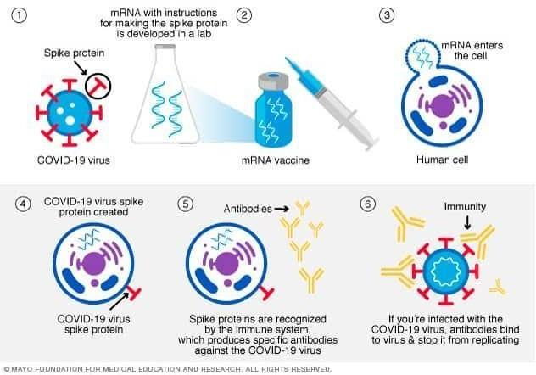

- FORENSIC-DNA FINGERPRINTING:

DNA fingerprinting, also called DNA typing, DNA profiling, genetic fingerprinting, genotyping, or identity testing, in genetics, method of isolating and identifying variable elements within the base-pair sequence of DNA (deoxyribonucleic acid).

The procedure for creating a DNA fingerprint consists of first obtaining a sample of cells, such as skin, hair, or blood cells, which contain DNA. The DNA is extracted from the cells and purified, the DNA was then cut at specific points along the strand with proteins known as restriction enzymes. The enzymes produced fragments of varying lengths that were sorted by placing them on a gel and then subjecting the gel to an electric current (electrophoresis): the shorter the fragment, the more quickly it moved toward the positive pole (anode).

The sorted double-stranded DNA fragments were then subjected to a blotting technique in which they were split into single strands and transferred to a nylon sheet. The fragments underwent autoradiography in which they were exposed to DNA probes—pieces of synthetic DNA that were made radioactive and that bound to the minisatellites. A piece of X-ray film was then exposed to the fragments, and a dark mark was produced at any point where a radioactive probe had become attached. The resultant pattern of marks could then be analyzed.
The DNA testing process is comprised of four main steps, including extraction, quantitation, amplification, and capillary electrophoresis.

DNA fingerprinting is a laboratory technique used to determine the probable identity of a person based on the nucleotide sequences of certain regions of human DNA that are unique to individuals. Forensic genetic fingerprinting can be defined as the comparison of the DNA in a person’s nucleated cells with that identified in biological matter found at the scene of a crime or with the DNA of another person for the purpose of identification or exclusion. The application of these techniques introduces new factual evidence to criminal investigations and court cases.

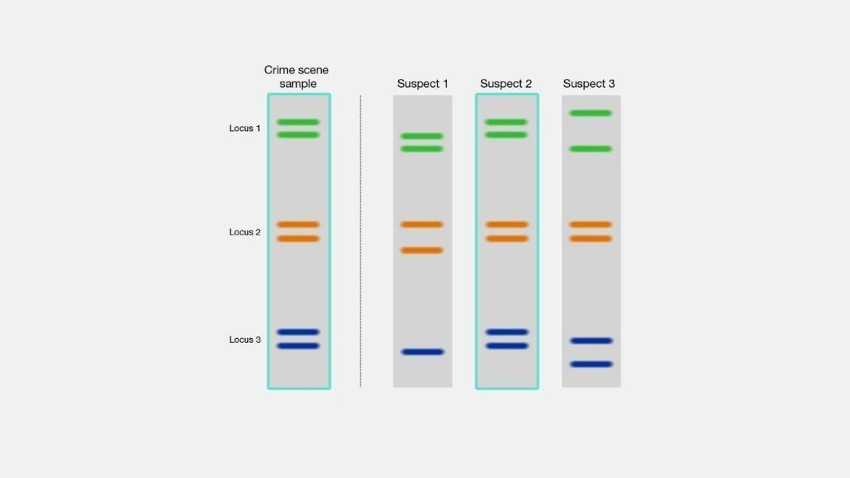
CUORTESY: LISA H CHADWICK

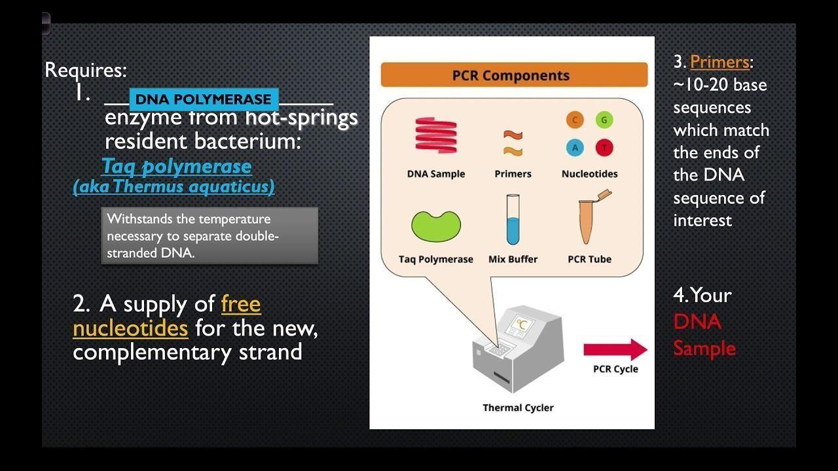
COURTESY: FORENSIC SCIENCE

DNA FINGERPRINTING

So, this is all about nucleic acids, considering the two main nucleic acids, that is, DNA and RNA, discussing about some of the most important applications of these nucleic acids.

PROTEINS:

Protein is found throughout the body—in muscle, bone, skin, hair, and virtually every other body part or tissue. It makes up the enzymes that power many chemical reactions and the hemoglobin that carries oxygen in your blood.
Talking more about proteins based on biomolecule concept, Proteins are large biomolecules and macromolecules that comprise one or more long chains of amino acid residues. Proteins perform a vast array of functions within organisms, including catalysing metabolic reactions, DNA replication, responding to stimuli, providing structure to cells and organisms, and transporting molecules from one location to another. Proteins differ from one another primarily in their sequence of amino acids, which is dictated by the nucleotide sequence of their genes, and which usually results in protein folding into a specific 3D structure that determines its activity.
Proteins are assembled from amino acids using information encoded in genes. Each protein has its own unique amino acid sequence that is specified by the nucleotide sequence of the gene encoding this protein. The genetic code is a set of three-nucleotide sets called codons and each three- nucleotide combination designates an amino acid.

The process of synthesizing a protein from an mRNA template is known as translation. The mRNA is loaded onto the ribosome and is read three nucleotides at a time by matching each codon to its base pairing anticodon located on a transfer RNA molecule, which carries the amino acid

corresponding to the codon it recognizes. The enzyme aminoacyl tRNA synthetase "charges" the tRNA molecules with the correct amino acids. The growing polypeptide is often termed the nascent chain. Proteins are always biosynthesized from N-terminus to C-terminus.
Proteins are the chief actors within the cell, said to be carrying out the duties specified by the information encoded in genes. With the exception of certain types of RNA, most other biological molecules are relatively inert elements upon which proteins act. Proteins make up half the dry weight of an Escherichia coli cell, whereas other macromolecules such as DNA and RNA make up only 3% and 20%, respectively. The set of proteins expressed in a particular cell or cell type is known as its proteome.

PROTEIN AS FOOD:

Protein is a key part of any diet. The average person needs about 7 grams of protein every day for every 20 pounds of body weight. Because protein is found in an abundance of foods, many people can easily meet this goal. However, not all protein “packages” are created equal. Because foods contain a lot more than protein, it’s important to pay attention to what else is coming with it.
Animal-based foods (meat, poultry, fish, eggs, and dairy foods) tend to be good sources of complete protein, while plant-based foods (fruits, vegetables, grains, nuts, and seeds) often lack one or more essential amino acid.

Whey protein is a mixture of proteins isolated from whey, the liquid material created as a by- product of cheese production. The proteins consist of α-lactalbumin, β-lactoglobulin, serum albumin and immunoglobulins. Glycomacropeptide also makes up the third largest component but is not a protein. Whey protein is commonly marketed as a protein supplement, and various health claims have been attributed to it.

Whey is left over when milk is coagulated during the process of cheese production, and contains everything that is soluble from milk after the pH is dropped to 4.6 during the coagulation process. It is a 5% solution of lactose in water and contains the water soluble proteins of milk as well as some lipid content. Processing can be done by simple drying, or the relative protein content can be increased by removing the lactose, lipids and other non-protein materials.
The primary usage of whey protein supplements is for muscle growth and development. Eating whey protein supplements before exercise will not assist athletic performance, but it will enhance the body's protein recovery and synthesis after exercise because it increases the free amino acids in the body's free amino acid pool.

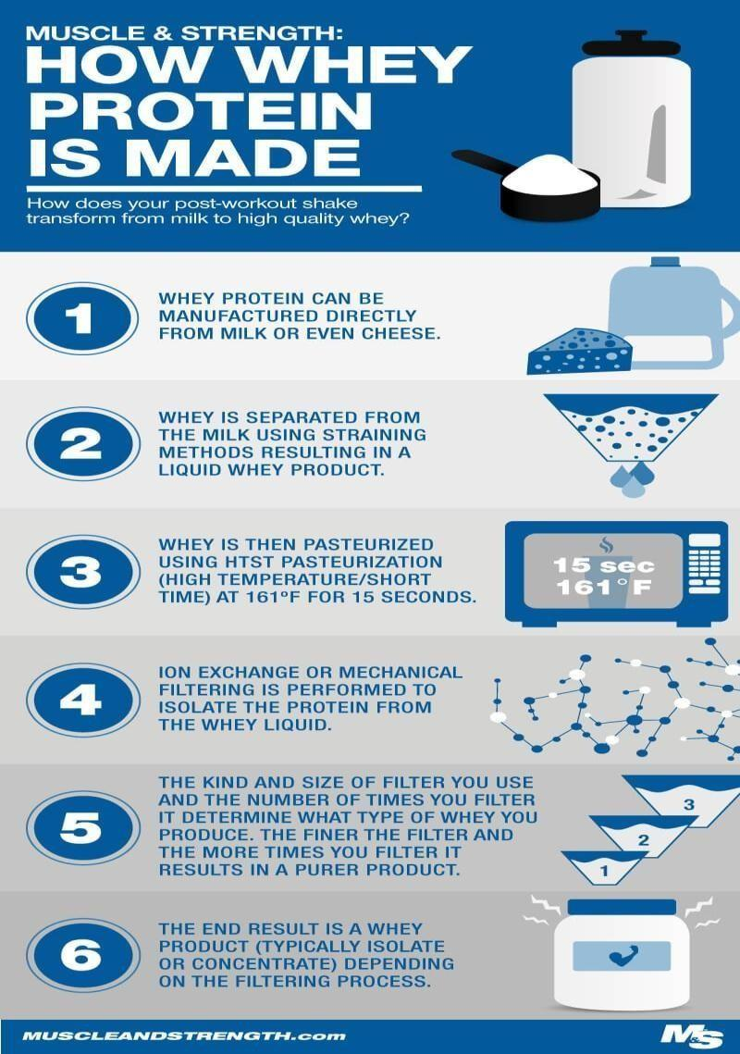

Meat analogues find raising interest of many consumers who are looking for indulgent, healthy, low environmental impact, ethical, cost-effective, and/or new food products. High moisture extrusion cooking enables the production of fresh, premium meat analogues that are texturally like muscle meat from plant or animal proteins. The appearance and eating sensation are similar to cooked meat while high protein content offers a similar nutritional value. This article focuses on plant-based meat analogues and covers process and product-related aspects including ingredients and structure formation, flavor, taste and nutritional value, postextrusion processing, packaging and shelf life, consumer benefits, and product-related environmental impacts.
Meat analogues, can be defined as products that mimic meat in its functionality, bearing similar appearance, texture, and sensory attributes to meat. Production of meat analogues has been on the increase, targeted at satisfying consumers’ desire for indulgent, healthy, low environmentalimpact, and ethical meat substitutes.

The factors that lead to this shift is due to low fat and calorie foods intake, flexitarians, animal disease, natural resources depletion, and to reduce greenhouse gas emission. Currently, available marketed meat analog products are plant-based meat in which the quality (i.e., texture and taste) are similar to the conventional meat. The ingredients used are mainly soy proteins with novel ingredients added, such as mycoprotein and soy leghemoglobin.

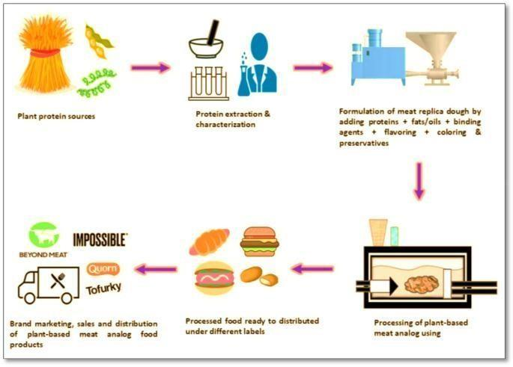
COURTESY: MEENAKSHI SINGH

PLANT BASED PROTEINS:

Plant protein is simply a meaningful food source of protein which is from plants. This group can include pulses, tofu, soya, tempeh, seitan, nuts, seeds, certain grains and even peas. Pulses are a large group of plants, which include chickpeas, lentils, beans (such as black, kidney and adzuki beans) and split peas.

Plant proteins are highly nutritious – not only as good sources of protein, but also because they provide other nutrients such as fibre, vitamins and minerals. Our intake of fibre tends to be too low, however by incorporating certain plant proteins into your diet, such as pulses, peas and nuts, you can easily boost your fibre intake.
Consumer demand for plant protein-based products is high and expected to grow considerably in the next decade. Factors contributing to the rise in popularity of plant proteins include: (1)potential health benefits associated with increased intake of plant-based diets; (2) consumer concerns regarding adverse health effects of consuming diets high in animal protein (e.g., increased saturated fat); (3) increased consumer recognition of the need to improve the environmental sustainability of food production; (4) ethical issues regarding the treatment of animals; and (5) general consumer view of protein as a “positive” nutrient (more is better). While there are health

and physical function benefits of diets higher in plant-based protein, the nutritional quality of plant proteins may be inferior in some respects relative to animal proteins.

LIPIDS:

Discussing about another important biomolecule, lipids, are a broad group of naturally occurring molecules which includes fats, waxes, sterols, fat-soluble vitamins (such as vitamins A, D, E and K), monoglycerides, diglycerides, phospholipids, and others. The functions of lipids include storing energy, signaling, and acting as structural components of cell membranes. Lipids have applications in the cosmetic and food industries, and in nanotechnology.

Lipids may be broadly defined as hydrophobic or amphiphilic small molecules; the amphiphilic nature of some lipids allows them to form structures such as vesicles, multilamellar/unilamellar liposomes, or membranes in an aqueous environment. Biological lipids originate entirely or in part from two distinct types of biochemical subunits or "building-blocks": ketoacyl and isoprene groups.Using this approach, lipids may be divided into eight categories: fatty acyls, glycerolipids, glycerophospholipids, sphingolipids, saccharolipids, and polyketides (derived from condensation of ketoacyl subunits); and sterol lipids and prenol lipids (derived from condensation of isoprene subunits).

A biological membrane is a form of lamellar phase lipid bilayer. The formation of lipid bilayers is an energetically preferred process when the glycerophospholipids described above are in an aqueous environment.This is known as the hydrophobic effect. In an aqueous system, the polar heads of lipids align towards the polar, aqueous environment, while the hydrophobic tails minimize their contact with water and tend to cluster together, forming a vesicle; depending on the concentration of the lipid, this biophysical interaction may result in the formation of micelles, liposomes, or lipid bilayers. Other aggregations are also observed and form part of the polymorphism of amphiphile (lipid) behavior.
Some of the applications are: Within the body, lipids function as an energy reserve, regulate hormones, transmit nerve impulses, cushion vital organs, and transport fat-soluble nutrients. Fat in food serves as an energy source with high caloric density, adds texture and taste, and contributes to satiety.

Lipid obtained from food waste was used as a potential feedstock for biodiesel production using both a chemical catalyst and a biocatalyst. Base (KOH) catalyzed transesterification of the lipid allowed a 100% conversion of biodiesel in 2 h; whereas, Novozyme-435 yielded 90% biodiesel in 24 h. So lipids are having a main application in bidiesel production.
Biodiesel demonstrates an animal fat-based or vegetable oil diesel fuel, including long-chain alkyl (methyl, ethyl, or propyl) esters. Biodiesel is generally made by esterifying lipids (e.g., soybean oil, vegetable oil, and animal fat (tallow)) with an alcohol generating fatty acid esters. Biodiesel is suggested to be utilized in standard diesel engines and is thus well defined from the vegetable and waste oils used to fuel converted diesel engines. Biodiesel can be used singly or blended with gasoline in any proportions. Biodiesel blends can also be utilized as heating oil.

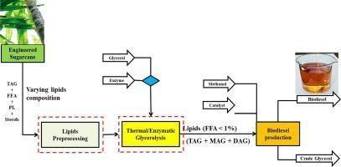
Biodiesel production
COURTESY: WEI JIN

Lipids also has an interesting application in cleaning agents. Considering the case of

DETERGENTS:

The hydrophobic end of the phospholipid bilayer stays away from the water. This avoids the dissolution of cell membrane in water. But the detergent can bind to the hydrophobic end of the cell membrane and form a solution with water, thus breaking the cell membrane barrier.
Detergent monomers solubilize membrane proteins by partitioning into the membrane bilayer. With increasing amounts of detergents, membranes undergo various stages of solubilization. The initial stage is lysis or rupture of the membrane.
While lipids also have the same general structure as detergents—a polar hydrophilic head group and a nonpolar hydrophobic tail— lipids differ from detergents in the shape of the monomers, in the type of aggregates formed in solution, and in the concentration range required for aggregation.
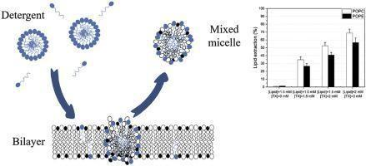
COURTESY: FAZAL SHAIK

ENZYMES:

Are another important biomolecule, which are proteins that help speed up metabolism, or the chemical reactions in our bodies. They build some substances and break others down. All living things have enzymes. Our bodies naturally produce enzymes.
The six kinds of enzymes are hydrolases, oxidoreductases, lyases, transferases, ligases and isomerases.

Enzymes perform the critical task of lowering a reaction's activation energy—that is, the amount of energy that must be put in for the reaction to begin. Enzymes work by binding to reactant molecules and holding them in such a way that the chemical bond-breaking and bond-forming processes take place more readily.
Due to their high specificity, simplicity, and scalability, enzyme-based biosensors represent a fast, precise, and continuous monitoring of analytes. Additionally, the high specificity of enzymes enhances the ability to detect lower analyte concentration limits. So enzymes are used in biosensors.

Biosensors are employed in applications such as disease monitoring, drug discovery, and detection of pollutants, disease-causing micro-organisms and markers that are indicators of a disease in bodily fluids (blood, urine, saliva, sweat).
Various types of biosensors being used are enzyme-based, tissue-based, immunosensors, DNA biosensors, and thermal and piezoelectric biosensors. There are wide variety of enzymes used in biosensors. One such enzyme is glucose oxidase, mainly in amperometric glucose biosensor.

GLUCOSE OXIDASE IN BIOSENSORS:

Glucose oxidase (GOx) is widely used enzyme in glucose biosensor due to its better stability and relatively inexpensive. GOx catalyses the redox reaction and transfer electrons from enzyme active sites to electrode for glucose level analysis in blood samples. Amperometric glucose biosensor was fabricated by immobilizing glucose oxidase (GOx). Glucose oxidase (GOx), the most popular enzyme used for glucose detection, is able to reduce oxygen to hydrogen peroxide while at the same time transforming glucose to d-glucono-1,5-lactone. Quantification of glucose can be achieved based on either the detection of the hydrogen peroxide produced or the oxygen consumed.

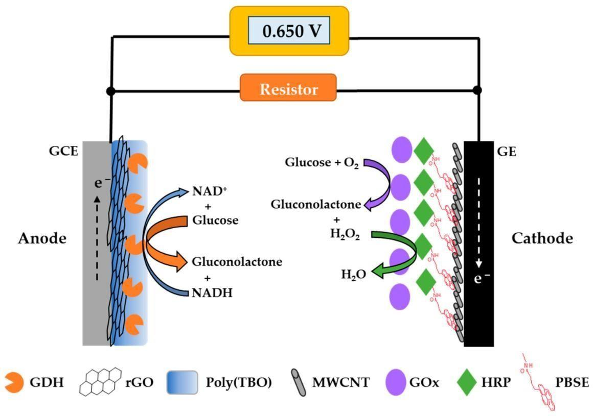
COURTESY: RESEARCH GATE

LIGNOLYTIC ENZYME IN BIO BLEACHING:

Ligninolytic enzymes play a key role in degradation and detoxification of lignocellulosic waste in environment. The major ligninolytic enzymes are laccase, lignin peroxidase, manganese peroxidase, and versatile peroxidase.
Ligninolytic fungi and enzymes (i.e., laccase, manganese peroxidase, and lignin peroxidase) have been applied recently in the production of second-generation biofuels.

White-rot fungi are the main producers of lignin-oxidizing enzymes. These fungi secrete a number of oxidative enzymes and some hitherto unknown substances (mediators) into their environment together effecting a slow but continuous degradation. The most important lignin-oxidizing enzymes are lignin peroxidases, manganese peroxidases and laccases. Lignin peroxidase and manganese peroxidase appear to constitute a major component of the ligninolytic system.

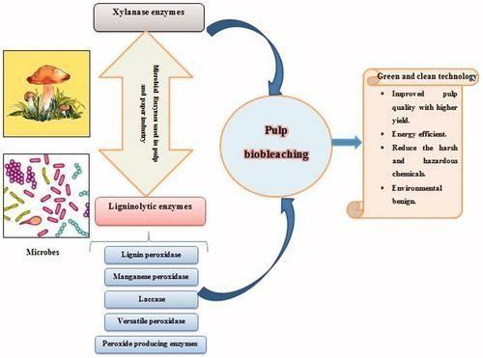
COURTESY:SHARDESH KUMAR CHAURASIA

Application of Enzymes in Food Processing

Enzymes are proteins which catalyse chemical reactions selectively as part of essential life processes such as digestion, respiration and metabolism in organisms. For centuries, human beings have exploited the impressive catalytic efficiency of these ubiquitous biomolecules for food processing, especially in the preparation of beer, wine, cheese and bread. Enzymes are generally extracted from edible plants and the tissues of animals. Certain enzymes also are produced by microorganisms like bacteria, yeasts, and fungi. Rennet, for instance, is a natural enzyme mixture from the stomach of calves and other domestic animals that has been used in the preparation of cheese. The industrial revolution also contributed to the growth of the enzyme industry particularly in applications like baking, beverages, brewing and dairy products. Additionally, enzymes also find applications in detergents, leather, textile pulp, and paper industries. A recent survey on world sales of enzymes ascribes 31% for food enzymes, 6% for feed enzymes and the remaining for technical enzymes.1
Some of the enzymes generally employed in food industry are listed below:
- Alpha-amylase: It is used to solubilize the carbohydrates found in barley and other cereals used in brewing.
- Beta-glucanase: Breakdown of glucans in malt and and other materials
- Lipase: Used to shorten the time for cheese ripening. It is employed in the production of enzyme-modified cheese/butter from cheese curd or butterfat.
- Papain: It is widely used as a meat tenderizer.
- Chymosin: Helps in the curdling of milk by breaking down kappa-caseins in cheese making.
- Microbial proteases: Used in the production of fish meals, meat extracts, texturized proteins, etc.
- Pectinase: Treatment of fruit pulp to facilitate juice extraction. It also helps in the clarification and filtration of fruit juice.
- Lactase: Additive for dairy products for individuals lacking lactase.
- Glucose oxidase: Conversion of glucose to gluconic acid to prevent Maillard reaction (reaction that gives browned food a particular flavor) in products caused by high heat used in dehydration.
- Cellulase: Conversion of cellulose waste to fermentable feedstock for ethanol or single-cell protein production.

In the past, the enzyme used in food processing was mostly derived from animal offal and plant extracts. Most of the enzymes used are now from microbial fermentation. In general, the purity of the enzyme used in food processing does not need to be particularly high, mostly partially purified enzyme. Unless in the special applications, such as proteolytic enzymes used in low-calorie beer, the higher the purity, the better the effect. Most enzymes applied in the food processing are glucoamylase and then followed by protease, lipase, esterase, oxidoreductase and isomerase.
Flour product
Enzyme, from organism and made with modern biotechnology, is a pure natural biological products and green food additives. It plays a significant role in a variety of special flour production and transformation. For instance, it can improve the baking quality, nutritional quality, texture, storage resistance and other functions of flour products.
Dairy processing

The main enzymes used in dairy processing are catalase and lactase. Catalase has high enzyme activity in bovine colostrum, mainly used for the removal of excess hydrogen peroxide in dairy products thereby to kill pathogens by using H₂O₂. Lactase can reduce the content of lactose to produce low lactose milk, low lactose hydrolyzed milk can improve the milk flavor, sweetness and nutritional value. In fermented milk, the use of lactase can accelerate the reaction and improve the fermentation efficiency to make fermented milk unique frankincense flavor and relatively extend shelf life of the product. Lactase used in condensed milk not only allows lactose to avoid lactose crystallization during concentration, but also make the product tasty, increase the sweetness, reduce the amount of sucrose, thereby inhibiting bacteria. The application of lactase in ice cream can not only increase the sweetness to reduce the amount of sucrose, but also solve the sediment due to the crystallization of deep frozen lactose, reduce the freezing point and improve the anti-thawing property. The use of lactase in milk powder can improve the flavor of milk powder, its rich caramel and caramel color after hydrolysis can produce chocolate milk.
Meat products processing

Enzyme used in the meat industry is mainly used to improve product quality (color, smell, taste, etc.) and increase the added value of by-products.
Beef products, treated with papain Ca ++ intensifier, have reddish brown color, crispy taste and good flavor, which completely overcomes traditional shortcomings including the tough taste, tenderness, gray color and low yield. The use of a certain amount of bromelain combined with phosphates, calcium chloride, etc. to tender mutton can improve the taste greatly. Lamb sausage produced with raw materials, which are treated with this method, has tender meat, good elasticity, unique flavor. It also makes up for the absence of lamb sausage in ham sausage. Transglutaminase can catalyze the formation of lysine covalent bonds between molecules of proteins or within molecules to form effective protein gels that impart specific hardness and elasticity to meat products.
In the deep processing of meat products, the use of protein complex enzymes can produce protein hydrolyzate. For instance, under the process conditions of pH value of 6.5-6.8, 55℃ and six-hour reaction, utilizing papain and bacillus subtilis neutral protease to hydrolyze snake meat, after proper purification, it can produce substances with rich nutrients and bioactive characteristics, and easy-to-degested nutrition solution. Bacillus subtilis neutral protease and pepsin hydrolize Maoshi pearl meat. Most of the protein in the hydrolyzate are converted to amino acids, which makes it delicious, lighter color and easy to be absorbed. These enzymes can be applied to the production of seafood seasonings, health drinks, etc.
Common by-products of meat processing are bone, bone crackers, mechanical flesh, fat and oil residue, which can be used as raw materials to obtain new meat extracts after enzymatic treatment. Meat extracts according to their characteristics and functions are divided into two categories: one is the flavor meat extract composed of small peptides and free amino acids; the other is a functional type of meat extract, generally composed of 10 amino acid molecules and with a moderate degree of hydrolysis. Flavor meat extracts have meat extract, bone soup or bone elements, etc. Such products with the natural aroma of raw materials can be made into paste or powder added to meat products, instant noodles seasoning package, sauce or snack foods, in order to enhance food flavor and protein content; what’s more, it can be precursor of flavors or meat flavor after further Maillard reaction. Functional meat extract can be treated in high temperature without protein denaturation. Due to the unique adhesive and water holding function, it can be used in sausage, ham and other products to improve the adhesive properties of the meat products, cutting, and reduce the loss of meat products during cooking.
Fruit and vegetable processing and beverage industry

Enzymes used in this area are mainly pectin, cellulase and amylase, and mostly are used alone or in combination. These enzymes are mainly used for peeling fruit, clarifying fruit juice, reducing the viscosity of fruit juice, increasing the rate of fruit juices, enhance stability, what’s more, they are also applied in making vegetable juice, extending the shelf life of fruits and vegetables, reducing nutrient loss and so on.
For example, under the condition of pH value of 4.0, 60℃ and four-hour reaction, adding cellulase (600U/100g), pectinase (1000U/100g), alpha-amylase (250U/100g) and papain (10000U/100g) to the clarification lychee juice process, and good clarity, low nutritional loss of high-quality lychee juice can be achieved.
Additionally, enzymes are also widely used in deep processing of tea. Tannase can improve the tea cold-soluble, prevent tea cloudy, and can improve the strength of the strength of tea. And now it is used in black tea, green tea and oolong tea. Cellulase and pectinase can break down the cell wall of tea, making the active ingredients of tea more easily to dissolve, improving the rate of instant tea products and, product clarity and the aroma of tea. Protease can improve tea extract rate and clarity, enhance the taste and improve the separation performance of tea.

Application of Enzymes in Detergent Industry

Enzymes find use as functional ingredients in detergents and contribute to cleaning of laundry and dishes in an efficient, environmentally mild, and energy-saving manner. Proteases, lipases, amylases are the major class of detergent enzymes, each provides specific benefits for application in laundry and automatic dishwashing. Proteases are the first to be used extensively in laundry detergents, which not only raise the level of cleaning, but also provide environmental benefits. Lipases and amylases are joined proteases in improving detergent efficacy, especially for household laundering at lower temperatures and, in industrial cleaning operations, at lower pH levels. Cellulases contribute to overall fabric care by rejuvenating or maintaining the new appearance of washed garments.
Detergent mechanism based on enzymes
From an enzyme point of view, detergents on the international market contain principal ingredients that operate by almost identical detergency mechanisms. Soil and stains are removed by mechanical action assisted by surfactants, builders, and enzymes. Alkaline proteases, amylases, or lipases in heavyduty detergents hydrolyze and solubilize substrate soil attached to fabrics or hard surfaces. Cellulases clean by hydrolysis of glycosidic bonds which removes particulate soils attached to cotton microfibers. Key effects of cellulases are to soften and improve the color brightness of worn textile surfaces. Surfactants lower the surface tension at interfaces and enhance the repulsive force between the original soil, enzymatically degraded soil, and the fabric. Builders act to chelate, precipitate or ion-exchange calcium and magnesium salts, to provide alkalinity, to prevent soil redeposition, to provide buffering capacity, and to inhibit corrosion.

Proteases
Proteases are the most widely used enzymes. In laundry detergents, protein stains such as grass, blood, egg, and human sweat are removed through proteolysis. In ADD, proteases secure the removal of proteinaceous food films, which are a particular problem with glassware and cutlery. Serine proteases are the most important group for detergent applications. Proteases catalyze the hydrolytic cleavage of the peptide chain. The most important parameters for the hydrolysis reaction are surface-available substrate S, E/S, pH, reaction time, and temperature. Together with the specificity and properties of the enzyme itself, these parameters are responsible for the course of reaction on a given protein stain.
Amylases
Native starch is only slowly degraded by α-amylases. Gelatinization and swelling are needed to make the starch susceptible to enzymatic breakdown. For most foods, various degrees of gelatinization result from cooking. Therefore, in detergents for laundry and automatic dishwashing, amylases facilitate the removal of starch-containing stains, e.g., pasta, potato, gravy, chocolate, and baby food. Amylases also prevent swollen starch from adhering to the surface of laundry and dishes that may otherwise act as a glue for particulate soiling. Complexes or reaction products between protein, starch, and/or fat are usually found in prepared foods. In such cases, enzyme synergy effects make it possible to remove soil even more efficiently than with single enzyme systems.
Cellulases
Cellulases cleave β-1,4-glucosidic bonds in cellulose and operate directly on the natural cotton fibers or cotton/flax blends and on the cellulose portion in synthetic fibers. Cellulases are applied in detergents to make cotton fabrics regain and maintain clear colors, a smooth surface, and softness. Cellulases provide these effects by shaving off the fuzz and pills of cotton fibrils that are generated on the fabric by normal wear and washing. Cellulases are unique in providing these effects.
Lipases
Because of their strong hydrophobicity, fats and oils are difficult to remove from laundry at low temperatures. Lipases hydrolyze triglyceride to more hydrophilic mono- and diglycerides, free fatty acids, and glycerol. These hydrolysis products are all soluble in alkaline conditions. In laundering, the effects of lipases are seen only after several wash cycles.

Application of Enzymes in Textile Industry

Enzymes, such as cellulases, catalase, and laccase, are commonly used in the textile industry. These enzymes are used to removing the starch, degrading excess hydrogen peroxide, bleaching textiles and degrading lignin. Because of the highly specific, efficient, non-toxic, and eco-friendly characteristics, the use of enzymes in the textile industry is rapidly growing. The application of cellulases for denim finishing and lactases for decolorization of textile effluents and textile bleaching are the most recent commercial advances. Furthermore, the use of enzymes results in reduced process times, energy and water savings, improved product quality and potential process integration.
Properties of enzymes used in textiles
Firstly, the enzyme accelerates the reaction by lowering the activation energy and remains intact at the end of the reaction by acting as a catalyst. Secondly, enzymes operate under a milder condition. Enzymes can be used in catalytic concentrations at low temperatures and at pH-values near to neutral. Thirdly, enzymes are the best alternative to toxic, hazardous, and polluting chemicals. Fourthly, enzymes act only on specific substrates, for example, enzymes used in desizing do not affect cellulose hence there is no loss of strength of cotton. Fifthly, enzymes are easy to control because their activity depends upon optimum condition. Sixthly, enzymes are biodegradable. At the end of the reaction in which enzymes used we can simply drain the remaining solution because enzymes are biodegradable and do not produce toxic waste on degradation hence there is no pollution.
Enzymes used in textile processing
- Enzymatic desizing
Amylases are used to remove starch-based size for improved and uniform wet processing in the textile industry. An amylase enzyme can be used for desizing processes at low-temperature (30-60ºC) and optimum pH is 5.5-6.5. The advantage of these enzymes is that they are specific for starch, removing it without damaging to the support fabric.
- Enzymatic Scouring
Scouring is the removal of non-cellulosic material present on the surface of the cotton. In generally cellulase and pectinase are combined and used for Bioscouring. In this pectinase destroy the cotton cuticle structure by digesting the pectin and removing the connection between the cuticle and the body of cotton fiber whereas cellulase can destroy cuticle structure by digesting the primary wall cellulose immediately under the cuticle of cotton.
- Enzymatic Bleaching
The purpose of cotton bleaching is to decolorize natural pigments and to confer a pure white appearance to the fibers. Mainly flavonoids are responsible for the color of cotton. The most common industrial bleaching agent is hydrogen peroxide. Conventional preparation of cotton requires high amounts of alkaline chemicals and consequently, huge quantities of rinse water are generated. However, radical reactions of bleaching agents with the fiber can lead to a decrease in the degree of polymerization and, thus, to severe damage. Therefore, replacement of hydrogen peroxide by an enzymatic bleaching system would not only lead to better product quality due to less fiber damage but also to substantial savings on washing water needed for the removal of hydrogen peroxide. An alternative to this process is to use a combination of suitable enzyme systems. Amyloglucosidases, pectinases, and glucose oxidases are selected that are compatible concerning their active pH and temperature range.
- Biopolishing
Biopolishing is a finishing process that improves fabric quality by mainly reducing fuzziness and pilling property of cellulosic fiber. The objective of the process is the elimination of micro fibrils of cotton through the action of cellulase enzyme. Biopolishing treatment brings the fabric a cleaner surface, a cooler feel, lustre, and softer feel.

